Inclusion and Diversity: Understanding Unconscious Bias

This workbook complements the Unconscious Bias webinar and has been developed to help you reflect on what you have learnt and the actions you can take to make changes. Please use it to capture your thoughts (and lightbulb moments!).

In this workbook you will:

- Be reminded of the key examples of unconscious bias

- Reflect on where bias comes from

- Identify your alarm bells

- Consider your experiences of bias

- Think about what you can do differently

How can we define unconscious bias?
“Unconscious Bias (or implicit bias) is often defined as prejudice or unsupported judgements in favor of or against one thing, person, or a group as compared to another, in a way that is usually considered unfair.”
Vanderbilt University

Activity 1
How would you define unconscious bias?

Examples of Unconscious Bias
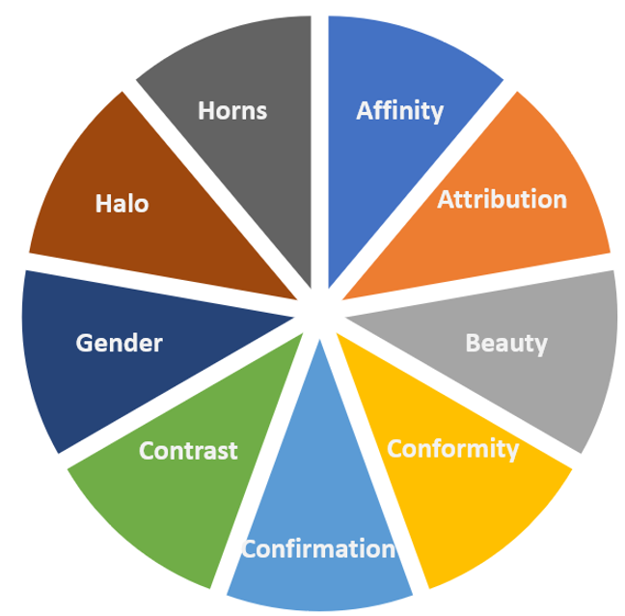

Bias | Description | My Experience
Affinity

Attribution

Beauty

Conformity

Confirmation

Contrast

Gender

Halo

Horns

Where Does Bias Come From?
Understanding how your life experiences shape your behaviours and actions.

Activity 2
Your key takeaways or reflections:

The Alarm Bell
Activity 3
Identify your alarm bells:

Prompter questions for you:

- What has rung your alarm bells?
- Where did you sense it?
- What would you attribute your gut reaction to?
- When thinking about your own inclusion and diversity experiences, what has made your alarm bells ring in those situations?

Experiencing Bias
OK versus Not OK
“Resentment is like taking poison and hoping it will hurt the person or situation you are blaming.”
Buddha

Activity 4
Consider your experience of bias:

“No-one can make you feel inferior without your consent.”
Eleanor Roosevelt

What positive actions could you take?

Next Steps

Activity 5
What will you do differently?
Take some time to think about your own experiences of bias, those that you have witnessed and those that you have been told about. Recognising bias is a key step in building and being part of a great inclusive and diverse culture.

What will I do differently after what I have heard today?

Who can I ask in my business for more information?
How can you find out more about what your organisation is doing in relation to inclusion and diversity and find out about other initiatives or ideas that may be upcoming/planned?

To find out more on this topic from IGD visit our website: Inclusion and diversity

